WHEN NATURE SPEAKS
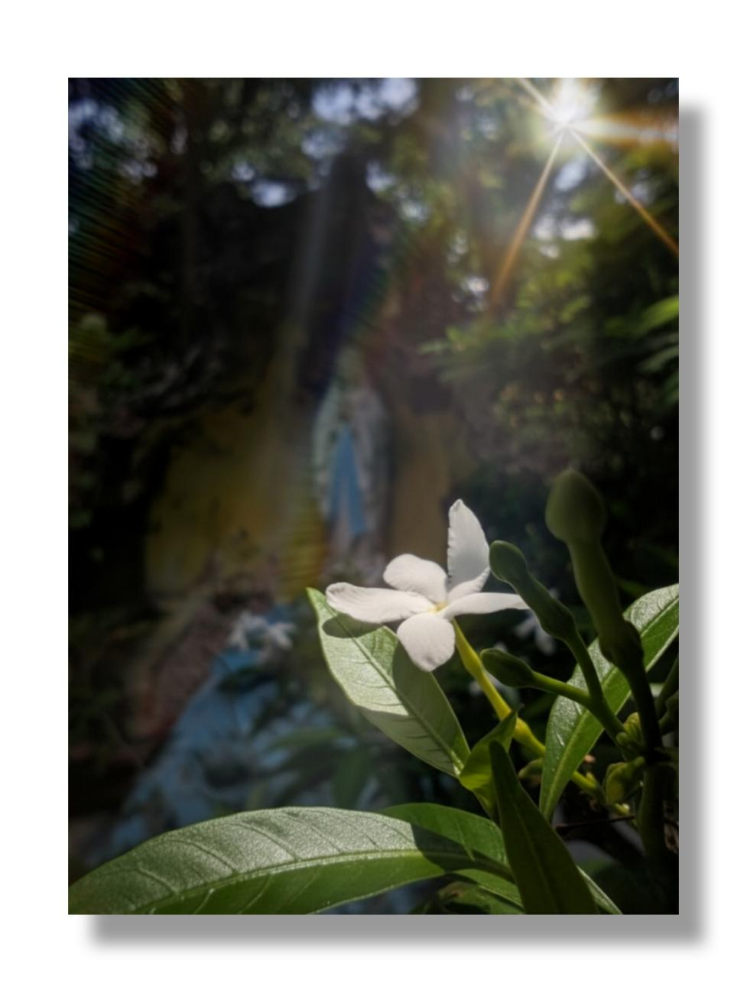

This is my entry for this activity. The focal point of this photo is the jasmine with its white and pure appearance it bloom and leans to the sunlight. The background of the jasmine plant is the Virgin Mary Statue which also symbolizes purity. The photo embodies gentleness, healing and a quiet sense of strength that flows through our hearts whenever we see the image. This photo shows that even in busy places like PUP Unisan campus where students wrestle and fight through their individual challenges, there is always a place and a pocket of piece, a guardian that is always there to guide us, and the flower that refreshes our minds whenever we see it. It’s a moment where nature, faith, and campus life braid into one scene. Because nature is not a place to visit, it is home

